**ACTIVITY 13**

**NAME : M.Varshini COURSE: MOBILE COMPUTING**

**REG NO : 192421293 COURSE CODE: ITA0302**

**13.Design an infographic in Figma comparing mobile communication and mobile**

**computing**

**Aim: -**

Using Figma design an infographic comparing mobile communication and mobile computing

Procedure: -

1. open Figma

2. Create a new file

3. Select the Frames

4. Fill in the content that is required for presentation

5. Design Visual Elements

6. Make it Interactive

7. Add Annotations and Explanations

8. Incorporate Multimedia

9. Storyboard Animation

11. Review and edit the Prototype

12. Save and Share

**Design: -**

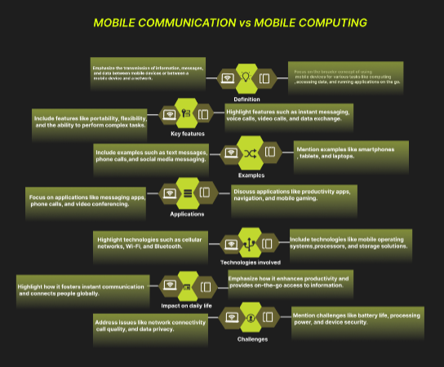

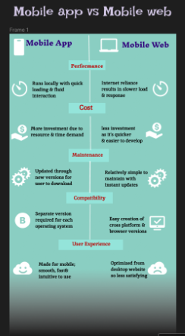

**Result: -**

An infographic design in Figma comparing mobile communication and mobile computing is

created successfully.